**Балтийский государственный технический университет**

**«Военмех» им. Д.Ф. Устинова**

**Кафедра И7**

**«Кафедра математической статистики и прикладной математики»**

**«Математическая статистика»**

Лабораторная работа № 3

«Моделирование некоторых распределений с помощью базовых случайных величин в пакете MathCAD»

Вариант 18

**Выполнил:**

Студент Тихонов А.Ю.

Группа И383

**Преподаватель:**

Гнидин В.В.

Санкт-Петербург

2011

**Probability Distributions**

Distribution: Geometric

|  |  |
| --- | --- |
| *Parameters:* | *Event Prob.* |
| Dist. 1 | 0,05 |
| Dist. 2 | 0,25 |
| Dist. 3 | 0,5 |
| Dist. 4 | 0,75 |
| Dist. 5 | 0,95 |

***The StatAdvisor***

*This procedure allows you to analyze any of 45 probability distributions. Currently, the Geometric distribution has been selected. You can create various plots, compute tail areas and critical values, and generate random numbers from the selected distribution. Up to five sets of parameters can be specified by pressing the alternate mouse button and selecting Analysis Options.*

**Cumulative Distribution**

Distribution: Geometric

Lower Tail Area (<)

|  |  |  |  |  |  |
| --- | --- | --- | --- | --- | --- |
| *Variable* | *Dist. 1* | *Dist. 2* | *Dist. 3* | *Dist. 4* | *Dist. 5* |
| 0,1 | 0,05 | 0,25 | 0,5 | 0,75 | 0,95 |
| 1 | 0,05 | 0,25 | 0,5 | 0,75 | 0,95 |
| 5 | 0,226219 | 0,762695 | 0,96875 | 0,999023 | 1,0 |
| 10 | 0,401263 | 0,943686 | 0,999023 | 0,999999 | 1,0 |
| 30 | 0,785361 | 0,999821 | 1,0 | 1,0 | 1,0 |

Probability Mass (=)

|  |  |  |  |  |  |
| --- | --- | --- | --- | --- | --- |
| *Variable* | *Dist. 1* | *Dist. 2* | *Dist. 3* | *Dist. 4* | *Dist. 5* |
| 0,1 | 0,0 | 0,0 | 0,0 | 0,0 | 0,0 |
| 1 | 0,0475 | 0,1875 | 0,25 | 0,1875 | 0,0475 |
| 5 | 0,038689 | 0,0593262 | 0,015625 | 0,000732422 | 2,96875E-7 |
| 10 | 0,0299368 | 0,0140784 | 0,000488281 | 7,15256E-7 | 9,27734E-14 |
| 30 | 0,0107319 | 0,0000446455 | 4,65661E-10 | 6,50521E-19 | 8,84756E-40 |

Upper Tail Area (>)

|  |  |  |  |  |  |
| --- | --- | --- | --- | --- | --- |
| *Variable* | *Dist. 1* | *Dist. 2* | *Dist. 3* | *Dist. 4* | *Dist. 5* |
| 0,1 | 0,95 | 0,75 | 0,5 | 0,25 | 0,05 |
| 1 | 0,9025 | 0,5625 | 0,25 | 0,0625 | 0,0025 |
| 5 | 0,735092 | 0,177979 | 0,015625 | 0,000244141 | 1,5625E-8 |
| 10 | 0,5688 | 0,0422351 | 0,000488281 | 2,38419E-7 | 4,88498E-15 |
| 30 | 0,203907 | 0,000133937 | 4,65661E-10 | 0,0 | 0,0 |

***The StatAdvisor***

*This pane evaluates the cumulative Geometric. It will calculate the tail areas for up to 5 critical values of the distribution. It will also calculate the probability density or mass function. For example, the output indicates that, for the first distribution specified, the probability of obtaining a value less than 0,1 is 0,05. Also, the probability of obtaining a value greater than 0,1 is 0,95. The probability of obtaining a value exactly equal to 0,1 is 0,0.*

**Inverse CDF**

Distribution: Geometric

|  |  |  |  |  |  |
| --- | --- | --- | --- | --- | --- |
| *CDF* | *Dist. 1* | *Dist. 2* | *Dist. 3* | *Dist. 4* | *Dist. 5* |
| 0,01 | 0 | 0 | 0 | 0 | 0 |
| 0,1 | 2 | 0 | 0 | 0 | 0 |
| 0,5 | 13 | 2 | 0 | 0 | 0 |
| 0,9 | 44 | 8 | 3 | 1 | 0 |
| 0,99 | 89 | 16 | 6 | 3 | 1 |

***The StatAdvisor***

*This pane finds critical values for the Geometric. You may specify up to 5 five tail areas. The critical value is defined as the largest value for the Geometric such that the probability of not exceeding that value does not exceed the area specified. For example, the output indicates that, for the first distribution specified, 0,0 is the largest value such that the probability of not exceeding 0,0 is less than or equal to 0,01.*

**Random Numbers**

To generate random numbers from the selected distribution, use the save button on the analysis toolbar.

Random numbers to be generated: 100

***The StatAdvisor***

*This pane allows you to specify the number of observations desired in a random sample from the Geometric. You set the number of observations by pressing the alternate mouse button and selecting Pane Options. After setting the size, press the Save Results button on the analysis toolbar. This allows you to save random samples from the specified distribution in columns of the current data file. Every time you select Save Results, a new random sample will be generated.*

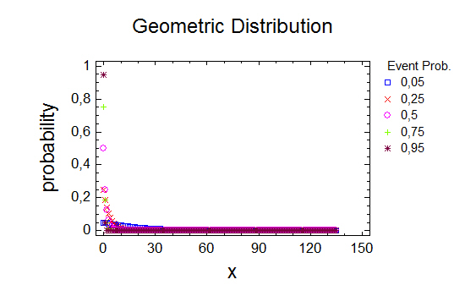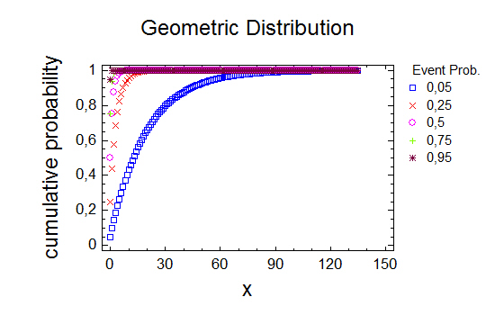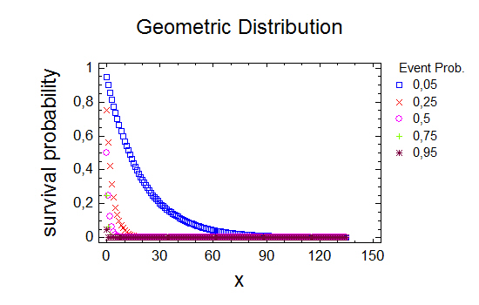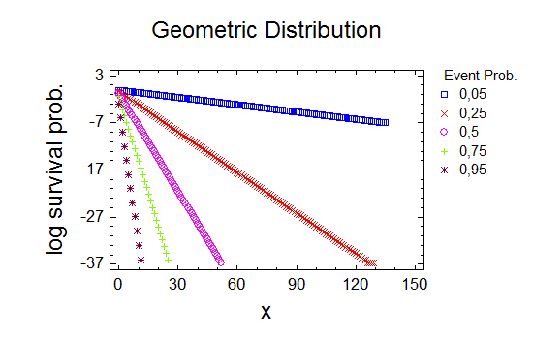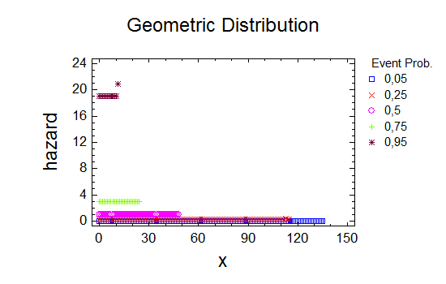







   







*Моделирование геометрического распределения:*



































*Генерирование выборки с помощью встроенной функции:*



























